Bereavement Walking Group Schedule

All walks begin at 1.30pm

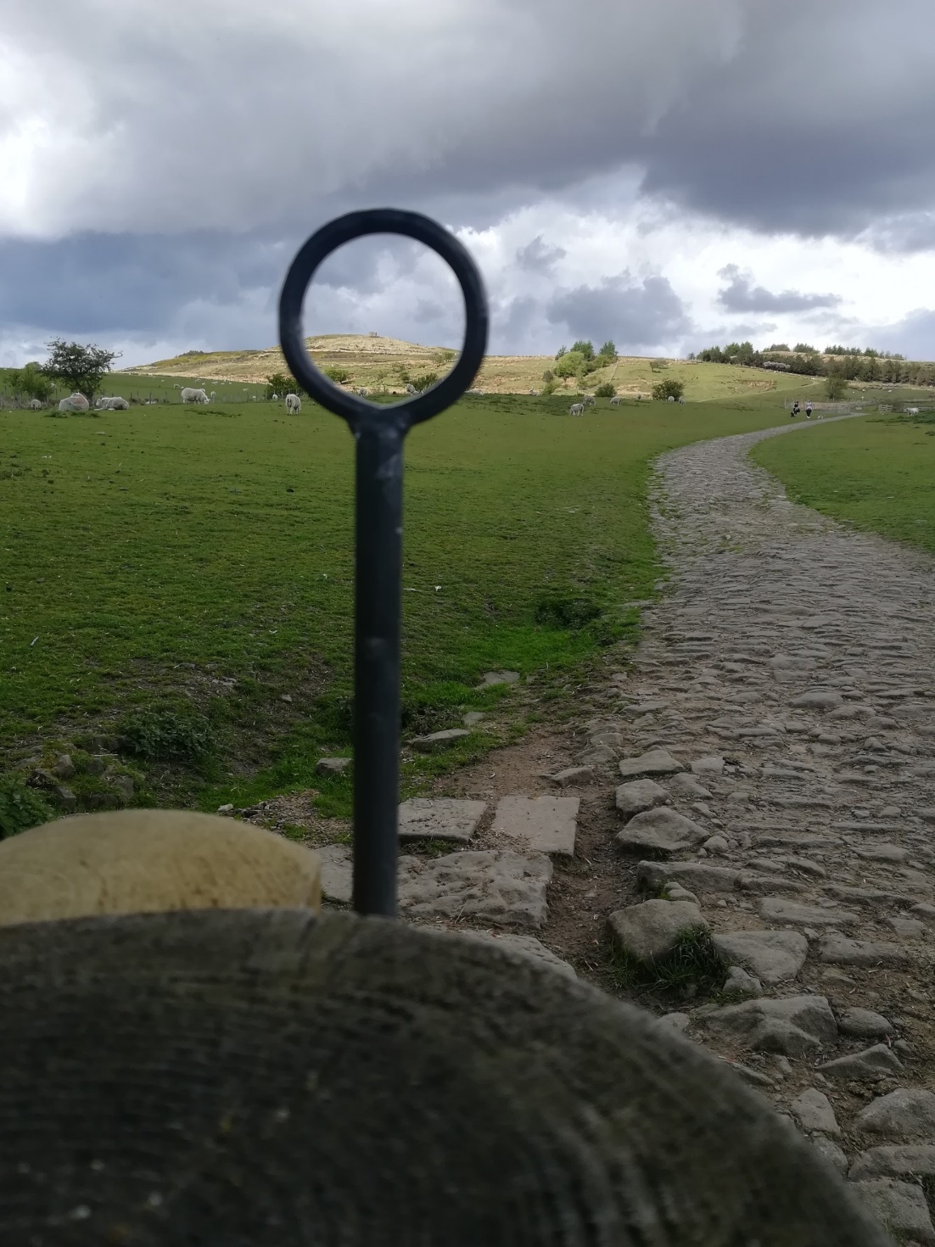

Monday October 4th at Rivington Barn 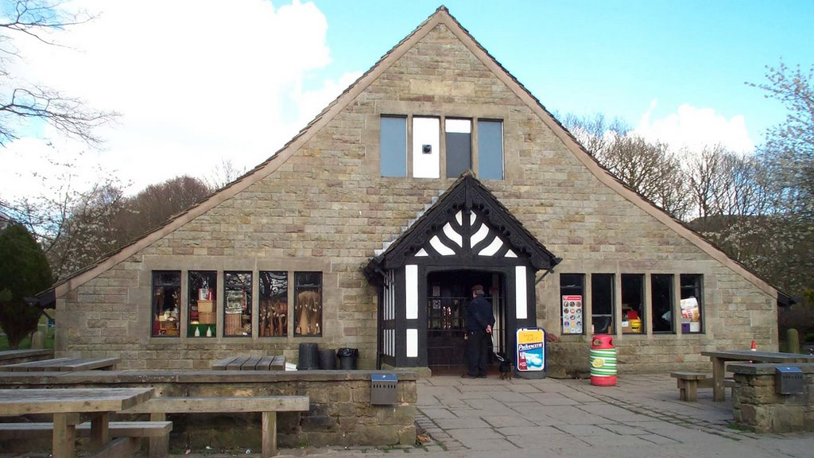meet in the car park.

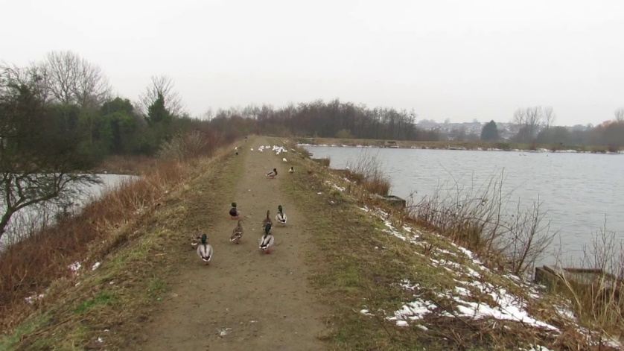Monday November 1st

at Starmount, meet at Bradley Fold Garden Centre car park.

**No walks in December/January**

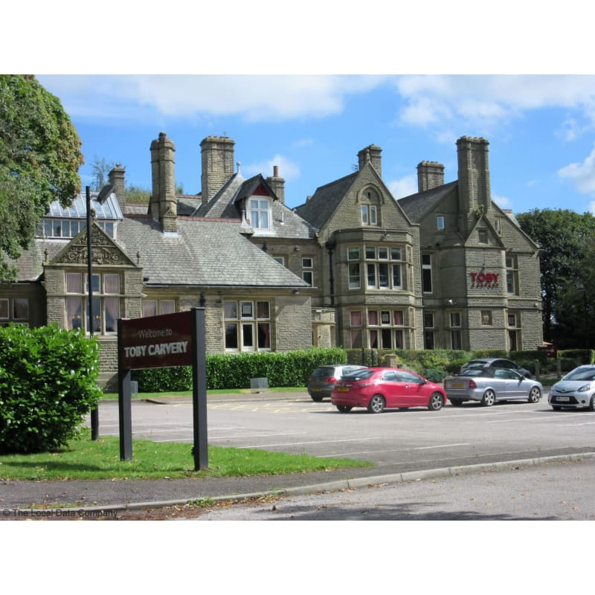

Monday 7th February 2022 hoping to try a meal out at the Watermillock Pub. If you would like to go please email John on [john.hall@boltonhospice.org](mailto:john.hall@boltonhospice.org) by January 27th.

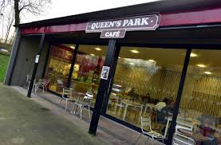Monday March 7th Queens Park, next to the Hospice, meet by the cafe, finish in the café!

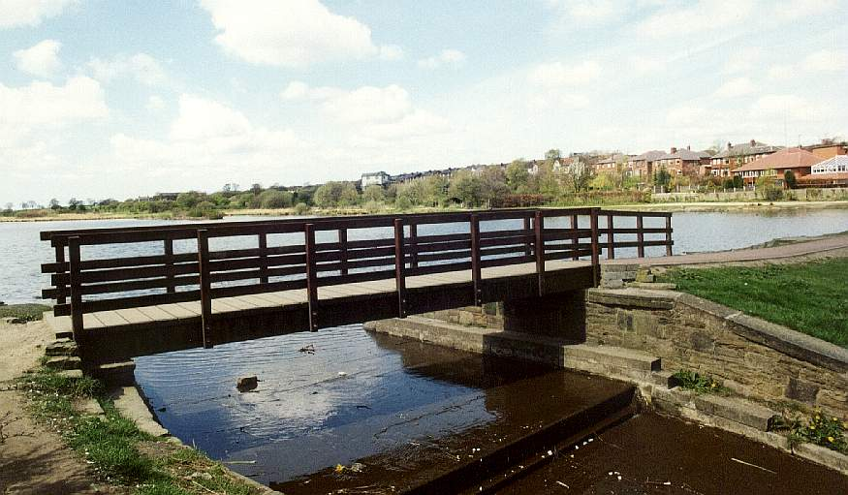Monday April 4th meet at Doffcocker car park. Finish for coffee at Café Italia.

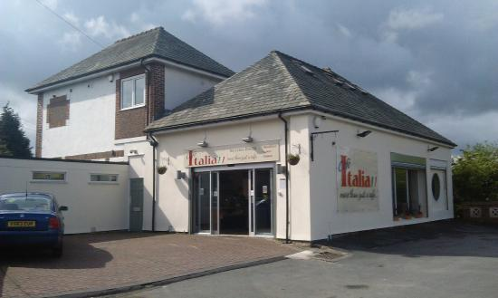

Monday May 9th at Smithills Country Park, Smithills Road, BL1 7NP ending in afternoon tea



Bereavement Walking Group Schedule

All walks begin at 1.30pm