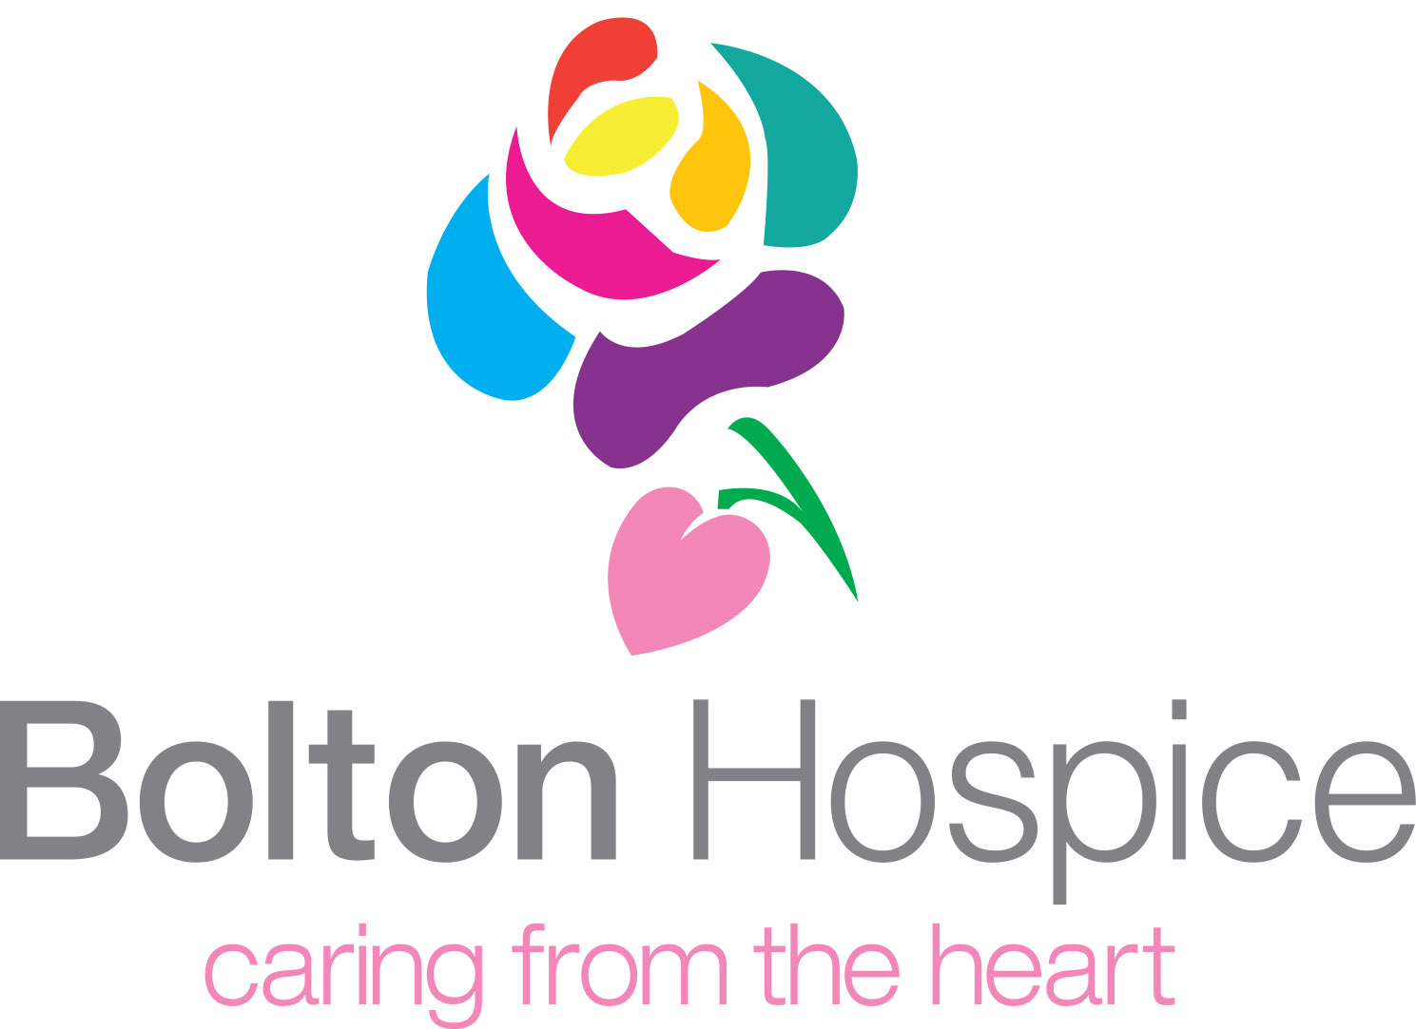

Booking Form
Bolton Hospice Golf Day
Thursday 27th July 2023, Bolton Golf Club
Name of team:……………………………………………………………………………………

Name of contact:………………………………………………………………………………..

Address:…………………………………………………………………………………….…….

………………………………………………………………………………………….….

Telephone no:……………………………………………………………………………………

Email………………………………………………………………………

Golf Team (4 players) entry includes:

- Sandwich lunch from 12.00pm
- 18 holes of golf for a team of 4 (shotgun start at 1.30pm)
- Carvery Dinner at 7.00pm
- Prizes
- On Course Drinks

I would like to book __________ team/s of 4 players for the Bolton Hospice Golf Day at a cost of £500.00 per team.

Pay by card

Please circle Visa / Mastercard / Switch (issue no)
Card No:

Valid From: Expiry Date:

Bacs to: Sort code 160006 Account no 11174594 Quote EVEGOLF23

Email booking form to: events@boltonhospice.org

Pay by cheque to ‘Bolton Hospice’

Return cheque and booking form to:
Bolton Hospice
Queens Park Street
Bolton BL1 4QT

Tel: 01204 663055 ext 3
Email: events@boltonhospice.org
www.boltonhospice.org.uk

