JOB DESCRIPTION
Job Title: | Bank Porter
Department: | Facilities
Post Holder: | tbc
Pay Scale: | Ancillary 2
Reports to: | Porter Supervisor
Accountable to: | Facilities Manager
Organisation Chart:
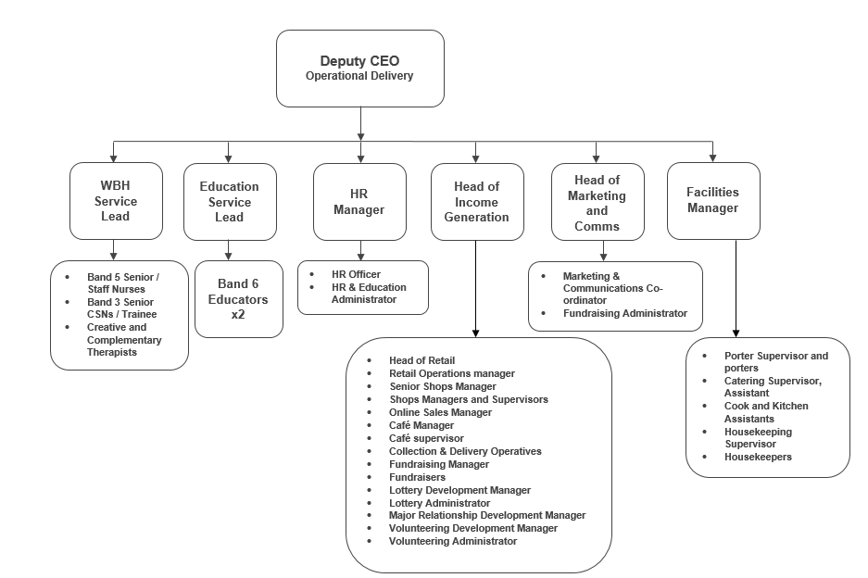
Job Purpose: | To monitor and maintain the general conditions of all areas of the hospice, reporting appropriate faults or problems to the correct departments.  To transport patients to and from the hospice throughout the day.  General maintenance of the hospice and its grounds.  To support the clinical and corporate service teams.
Key Working Relationships: | All clinical and corporate teams in BHSS, IPU and Giles House

The duties and responsibilities of this post have been assessed as levels of competence required and reflect the skill and knowledge needed to satisfactorily perform the duties of the post.
Role Responsibilities:
Security
- Secure windows, doors and shutters and engage alarms at the end of shift (Giles House, BHSS, Prayer & Reflection Room and IPU)
- Keep all doors and windows to non-public/patient areas (i.e. outer doors, kitchen and flower room) closed for security and safety reasons
- Be constantly aware of people in and around the hospice and report any untoward sightings or incidents
- Carry out and record security checks and additional security checks in the evenings
Maintenance
- Check Porters’ log on a regular basis
- Change lightbulbs/batteries when necessary
- Undertake maintenance as required
- Collection and delivery of goods
- Constantly view all areas for faults, fixing and/or reporting any faults to Estates or as appropriate
- Ensure paintwork is in good repair, reporting any damaged or peeling paint to line manager
- Safely store delivered stock
Ground Maintenance
- Ensure outside environment is safe, clean and presentable
- Keep patios, car parks and pathways free from litter
- Keep all outer buildings clean and tidy, free from rubbish, flammable materials and unsafe equipment/materials
- Clean outside woodwork, patios and garden furniture on a regular basis
Patient Transport
- Transport patients to and from the hospice, with assistance from nursing staff
- Ensure all policies and procedures are followed
- Ensure safety equipment is checked daily
- Complete all vehicle checks required and log in appropriate file
- Ensure hospice minibus and all other hospice vehicles are clean at all times
- Report any incidents to line manager in first instance and the Finance & Corporate Services Director will need to be informed if there is any cost implication
General
- Carry out and record sanitary checks in key patient areas and reception
- Set up meeting rooms on a daily basis, including moving and arranging furniture as required
- Clear rubbish from all areas, including Giles House
- Clear clinical waste from wards (bins and bags), following the correct procedures
- Undertake inspections of toilet areas in the absence of Housekeepers, cleaning as required and reporting on appropriate record log
- Ensure bins in all areas are checked regularly and emptied when necessary
- Cleaning duties throughout the hospice, as requested in the work files kept in the Porters’ room
- 24/7 role guidance is kept in a file in the Porter’ room. Ad hoc requests and duties can, and on occasion, will be requested
- Be flexible in order to cover the needs of a 24/7 service role

General Responsibilities:
Health and Safety
All staff have a duty to report and accidents, complaints, defects in equipment, near misses and untoward incidents, following hospice procedure.
Ensure health and safety legislation is complied with at all times, including COSHH and Workplace Assessment.
Confidentiality
All information relating to patients, patients’ families, staff, volunteers, supporters and suppliers gained through your work with Bolton Hospice is confidential. Disclosure to any unauthorised person is a serious disciplinary offence.
Infection Control
Prevent spread of infection. Comply with policies and procedures for correct disposal of waste, sharps and soiled linen.
Training
Managers are required to take responsibility for their own and their staff’s development. All staff have a duty to attend training as required by the Hospice.
Safeguarding Vulnerable People (Children and Adults)
All staff have a responsibility to protect and safeguard vulnerable people (children and adults). They must be aware of child and adult protection procedures and who to contact within the Hospice for further advice. All staff are required to attend safeguarding awareness training and to undertake additional training appropriate to their role.
Disclosure & Barring Service Check
This post is subject to a Disclosure & Barring Service check.
The range of duties and responsibilities outlined above are indicative only and are intended to give a broad flavour of the range and type of duties that will be allocated. They are subject to modification in the light of changing service demands and the development requirements of the post holder.
This job description is an outline of the main responsibilities. It will be subject to periodic review and amendment.
Staff Name:
Staff Signature: |  | Date:

Manager Name:
Manager Signature: |  | Date:

PERSON SPECIFICATION

Job Title: | Porter
Department: | Facilities
Pay Scale: | Ancillary 2

The person specification sets out the qualifications, experience, skills, knowledge and personal attributes which the post holder requires to perform the job to a satisfactory level.

 | ESSENTIAL | DESIRABLE | METHOD OF ASSESSMENT
EXPERIENCE | Experience working in a similar role | Experience of working with the general public  Experience of dealing with security issues | Application Form  Interview
SKILLS | Excellent interpersonal and relationship-building skills  Excellent communication skills- able to communicate effectively at all levels | Computer literate | Application Form  Interview
KNOWLEDGE | Maintenance knowledge  Good understanding of work logs/schedules  Health & safety knowledge | Knowledge of oxygen management | Application Form  Interview
PERSONAL ATTRIBUTES | Self-motivated and able to use initiative  Non-judgemental and empathetic approach  Flexible approach to work duties  Strong teamwork ethic  A commitment to the vision and values of Bolton Hospice.  Full, clean driving licence |  | Application Form  Interview

