JOB DESCRIPTION
Job Title: | Macmillan Cancer Information and Support Service Deputy Manager
Department: | Macmillan Cancer Information and Support Service
Employer Base: | Bolton Hospice
Post Holder: | TBC
Grade: | A&C Band 6
Reports to: | MCISS Manager
Organisation Chart:
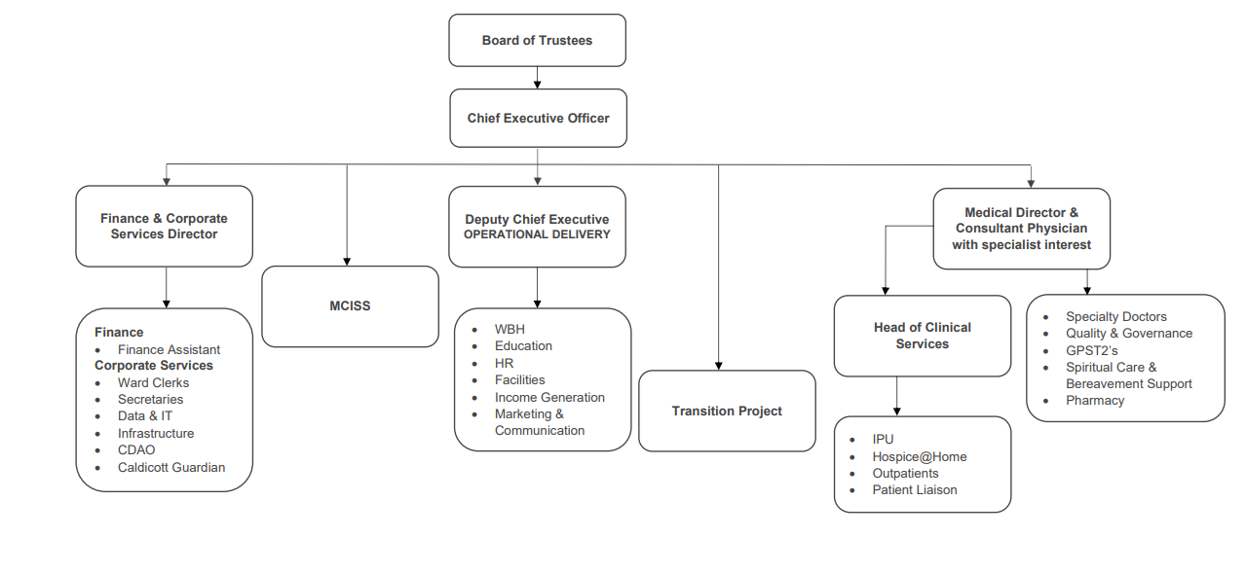
The duties and responsibilities of this post have been assessed as levels of competence required and reflect the skill and knowledge needed to satisfactorily perform the duties of the post.
Job Purpose: | Supporting the Macmillan Cancer Information and Support Service Manager in developing and delivering the Macmillan Cancer Information and Support Service in Bolton. Supporting the MCISS assistants and volunteers in their day-to-day duties.  To ensure access for service users to accurate, high-quality information and empathetic support, linking with other information providers and support mechanisms both nationally and locally.  To be a specialist information and support resource for health and social care professionals, providing expertise that enhances the skills of the clinical teams.  To support the manager to develop and implement the vision and strategy for cancer information and support across Bolton.  Support the manager to ensure that the service operates in partnership with the clinical teams to supports the Personalised Care Agenda for people living with or beyond cancer.  To ensure that the service operates in partnership with and is supportive of the aims and values of Bolton Hospice, Macmillan Cancer Support, Greater Manchester Integrated Care and Bolton People affected By Cancer user group.
Key Working Relationships: | Macmillan Cancer Information and Support Service team  Chief Executive (Bolton Hospice)  Lead Cancer Nurse & Cancer Nurse Specialists (Bolton Foundation Trust)  Bolton PAC Group  UCAN Centre Managers  Bolton Libraries Managers  Volunteers  Macmillan  Bolton Council

Role Responsibilities:
Operational/ Managerial

- Support development and co-ordinate information and support services across a range of settings within Bolton and take responsibility for creation and implementation of all relevant policies.
- Development will also involve extensive planning and co-ordination with other professionals and agencies, to ensure the efficient and effective running of these services.
- To utilise experience and knowledge of the NHS and external agencies to maximum potential in outreach activities, promotion, and continued development of the service. Develop links with similar services across Greater Manchester
- To identify evaluate, recommend, and implement new initiatives to improve the effectiveness and efficiency of the service ensuring the maintenance of high-quality standards.
- Support the managers to facilitate process redesign and service re-engineering, where necessary, with the aim of making the best use of available resources and improving the patient experience.
- To organise one’s own workload within the autonomous nature of the role. This demands flexibility to manage the unpredictable pattern of the work, which fluctuates from immediate response of the ‘drop in’ service to intense concentration when exposed to distressing and emotional circumstances.
- To have a level of responsibility for the management and provision of services offered in the Centre and to develop outreach across Bolton by the team of paid staff and volunteers, in the absence of the managers.
- To be involved in the line management of the MCISS team, supported by the MCISS Manager this includes paid and volunteer staff. Ensuring Hospice personnel management and disciplinary policies are complied with, this may include annual Individual performance Review and all staffing issues for the Macmillan Cancer Information & Support Service staff.
  - To support the MCISS manager with interviewing, recruitment and appointment of new paid staff and volunteers to work in the Centre in accordance with HR policies. To liaise with and work in partnership with the Hospice volunteer co-ordinator to ensure Hospice procedures for selection, training and support of volunteer staff are adhered to.

  - You will be responsible for the centres in the absence of the manager, ensuring all client interactions (Centre visits, telephone, email) are fully and accurately documented. This includes the day to day running of the centres, for example stock, and keeping up-to– date rotas etc.
  - To support with publicity and marketing for the service and ensure it is high quality and high profile to ensure all patients are aware of the services provided.
  - In the absence of the manager attend the quarterly Macmillan Cancer Information & Support Service Monitoring Group meetings, ensuring representation from relevant stakeholders, including Macmillan Cancer Support.
- Bolton covers a wide geographical area incorporating three drop-in centres. Travel between these sites is necessary, as is the ability to travel to various outreach locations for education/conferences.
- To support the plan and development of the service including short/ long term goals and objectives for the service.
- To adhere to all National Guidelines on patient information.
- Contribute to the development and maintenance of effective relationships with key stakeholders.
Information and Support
- Communicate sensitively and compassionately in potentially high emotive situations with clients (patients/families/carers) who may be very distressed.
- Interpret and assess enquiries from the public and health care professionals. Exercise judgement in identification of their needs of the service and provide appropriate information that potentially can be highly sensitive and emotive.

- Provide both practical and emotional support for visitors, giving them the opportunity to acknowledge and express their concerns in a safe environment.

- Promote patient/user participation in the development of the service and facilitate Bolton PAC for this participation.

- Regular support the development and review of patient information literature materials.

- Emotional empathy is required as people affected by cancer may be extremely distressed at the time of their visit to the Information Pods. You will also provide support & guidance to staff and volunteers during higher level interactions.

Education and Training
- Support and deliver educational events, both internally and externally, which are relevant for Macmillan Cancer Information and Support Service users and professionals. This may also include booking venues, developing, and distributing flyers and registering attendees.
- Support the delivery of pre-defined training to volunteers, centre users and staff from other departments, and using the system to retrieve resources for visitors to the centre.
- Keep up to date with current relevant issues and developments in cancer and palliative care.
- Assist in the co-ordination, mentoring and training of newly appointed volunteers and staff, supporting them during their induction.
- Demonstrate a willingness to identify own learning and development needs and be willing to undertake further study to address these needs.

Project Support
- Set up and maintain project files and collect actual data and forecasts.
- Administer or assist the Monitoring Group Meetings.
- Assist with the compilation and review of reports and update plans. In the absence of the manager, you will be responsible to complete this.
- Maintain service records and registers with the guidance of the Service Manager.
- Ensure the security and preservation of the master copies of all project products.
- Maintain a record of all copies issued.
- Notify holders of any changes to their copies.
- Number, record, store and distribute reports.
Working Conditions
- Lone worker for majority of patient intervention.
- Exposed to distressing situations on a regular basis.
- Frequent periods of intense concentration.
Other
- Work within agreed hospice policies, procedures, and guidelines.
- Work as an integral part of the team, being sensitive to the needs of the whole team and supportive of other team members.
- Participate in an annual appraisal and undertake training to maintain and develop knowledge and skills as required.
- Any other duties as deemed necessary by the Service Managers.

Policies and Procedures
Health and Safety
All employees have a duty to take reasonable care to avoid injury to themselves or to others and to co-operate with Bolton Hospice. All employees have a duty to report and accidents, complaints, defects in equipment, near misses and untoward incidents, following hospice procedure. Ensure health and safety legislation is always complied with, including COSHH and Workplace Assessment.
Confidentiality
All information relating to patients, patients’ families, staff, volunteers, supporters, and suppliers gained through your employment with Bolton Hospice is confidential. Disclosure to any unauthorised person is a serious disciplinary offence.
Infection Control
Prevent spread of infection. Comply with policies and procedures.
Training
Managers are required to take responsibility for their own and their staff’s development. All employees have a duty to attend training as required by the Hospice.
Safeguarding Vulnerable People (Children and Adults)
All employees have a responsibility to protect and safeguard vulnerable people (children and adults). They must be aware of child and adult protection procedures and who to contact within the Hospice for further advice. All employees are required to attend safeguarding awareness training and to undertake additional training appropriate to their role.
Disclosure & Barring Service Check
This post is subject to a Disclosure & Barring Service check.

Valuing Equality and Diversity
All hospice staff should carry out their duties in accordance with the values and principles of our Equality and Diversity strategy. It is the responsibility of all employees to support the hospice commitment to do all we can to ensure we do not exclude, alienate, or discriminate in any way and to promote a positive attitude to equality and diversity in adherence to our Equality and Diversity policy.
The range of duties and responsibilities outlined above are indicative only and are intended to give a broad flavour of the range and type of duties that will be allocated. They are subject to modification in the light of changing service demands and the development requirements of the post holder.
This job description is an outline of the main responsibilities. It will be subject to periodic review and amendment.
Employee Name:
Employee Signature: |  | Date:

Manager Name:
Manager Signature: |  | Date:

PERSON SPECIFICATION

Job Title: | Macmillan Cancer Information and Support Service Manager – Operational Lead
Department: | Macmillan Cancer Information and Support Service
Grade: | A&C Band 6

The person specification sets out the qualifications, experience, skills, knowledge, and personal attributes which the post holder requires to perform the job to a satisfactory level.

 | ESSENTIAL | DESIRABLE | METHOD OF ASSESSMENT
QUALIFICATIONS | Educated to degree level in relevant subject or equivalent level of experience of working at a similar level in specialist area. | Advanced Communication Skills or equivalent.  Teaching and assessing qualification.  Experience of working as a Health Professional. | Application Form  Certificates
EXPERIENCE & KNOWLEDGE | Experience of working in a healthcare environment.  Evidence of continued professional development.  Knowledge of cancer, its treatments, and available services.  Line-management, project management or supporting change management experience.  A thorough understanding of the importance of providing clear accessible information for people with a life-threatening illness.  Experience of teaching staff from own profession and other disciplines.  Experience of educating the public.  Experience of working with easy to miss groups.  Experience in service evaluation, producing analytical reports for presentation to senior levels within and outside of the service.  Experience of supporting recruitment, training, managing and supervising volunteers.  Ability to use judgment about levels of intervention required by different clients.  Ability to undertake self-directed learning.  Working knowledge of NICE guidelines and how they apply to information.  Understanding of safeguarding policies/ cancer related emergencies and ability to triage the urgency of situations. | Experience of working in an oncology/cancer care environment.  Knowledge of other life-threatening illnesses and where to access help. | Application Form  Interview
SKILLS | Strong organisational and administrative skills, including being able to concentrate on data analysis, whilst prioritising own workload and meet deadlines as necessary.  Excellent communication skills / ability to communicate complex, sensitive information in an empathetic manner in highly emotive atmospheres, and effectively at all levels.  Ability to support the development and delivery of education programmes to the public and staff.  Ability to produce clear, written, evidence-based reports and to communicate well, both verbally and in writing.  Excellent presentation skills – able to present complex issues both formally and informally.  Able to offer specialist support to staff and service users.  Able to support development of clinical evaluation, audit, and research.  Ability to promote effective team working.  Ability to communicate well with clients / families / carers and healthcare professionals.  Vision and ability to support development of the service in conjunction with a wide range of stakeholders.  Ability to contribute at a local level on the development of cancer services.  Able to develop effective interpersonal relationships with colleagues across a health and social care setting. | Working knowledge of health and wellbeing issues, the NHS and support services | Application Form  Interview
 | ESSENTIAL | DESIRABLE | METHOD OF ASSESSMENT
PERSONAL ATTRIBUTES | Able to recognise and work within the limit of own competence and responsibility.  Self-motivated and able to use initiative.  Strong teamwork ethic.  Shows independent judgement, while operating within procedural guidelines  Ability to remain calm in stressful situations.  A commitment to the vision and values of Bolton Hospice. | Clean driving licence and access to a vehicle insured for business use subject to the Equality Act 2010. | Application Form  Interview

