JOB DESCRIPTION

Job Title: | Shop Supervisor (Bank)
Department: | Income Generation
Post Holder: | tbc
Rate: | Admin 1
Reports to: | Shops Manager
Accountable to: | Retail Operations Manager/Head of Retail

Organisation Chart: 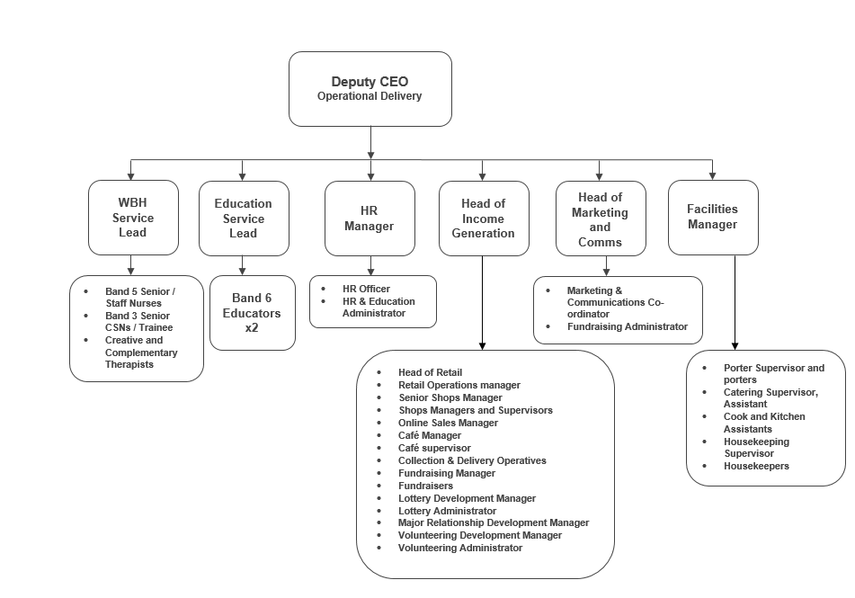
The duties and responsibilities of this post have been assessed as levels of competence required and reflect the skill and knowledge needed to satisfactorily perform the duties of the post.
 | Job Purpose: | To support the effective operation of the hospice’s retail operations during periods of staff leave, absences and during busy periods.

Key Working Relationships: | Retail team  Income Generation & Communications team  Volunteers  Donors and Customers

Role Responsibilities:
- Provide practical support in the operation of the hospice’s retail operations as required.
- Provide high levels of customer service and effectively deal with any customer complaints.
- Work closely with volunteers to ensure required standards and procedures are consistently maintained.
- Deliver training to volunteers as required.
- Create a positive and supportive working environment for volunteers, ensuring everyone works towards the ultimate objective of raising funds for Bolton Hospice.
- Be aware of and work towards achieving set targets.
- Ensure all areas are kept clean and tidy.
- Handover important information to other staff to ensure operations are consistently maintained.
- Use EPOS tills and undertake cash handling and financial procedures including cashing up, reconciliation, managing floats, petty cash and banking.
- Close the premises safely and securely at the close of business.
- Have excellent IT skills and good attention to detail.
- Deal with donations coming into the shop, sorting into rag, waste and saleable items.
- Price all saleable stock using the price guide and week number procedure.
- Process gift aid on donated goods into the shop and promote gift aid with all volunteers, following the system through to labelling clothing items with the bar codes.
- Replenish stock regularly and on demand.
- Maximise profits for the hospice by directing higher value items to alternative sales outlets.
- Store waste items in the correct location as per hospice shop procedures.
- Maintain a high standard of merchandising and display, both in the window and on the shop floor, to ensure the shop is fully stocked with clean, saleable goods.
Other
- Work within agreed hospice policies, procedures and guidelines.
- Work as an integral part of the team, being sensitive to the needs of the whole team and supportive of other team members.
- Undertake training to maintain and develop knowledge and skills as required.
- Any other duties as deemed necessary by the Shops Manager, Assistant Head of Retail or Head of Retail.

General Responsibilities:
Health and Safety
All employees have a duty to take reasonable care to avoid injury to themselves or to others and to co-operate with Bolton Hospice.
Confidentiality
All information relating to patients, patients’ families, staff, volunteers, supporters and suppliers gained through your employment with Bolton Hospice is confidential. Disclosure to any unauthorised person is a serious disciplinary offence.
Infection Control
Prevent spread of infection. Comply with policies and procedures for correct disposal of waste, sharps and soiled linen.

Training
Managers are required to take responsibility for their own and their staff’s development. All employees have a duty to attend training as required by the Hospice.
Disclosure & Barring Service Check
This post is subject to a Disclosure & Barring Service check.
Safeguarding Vulnerable People (Children and Adults)
All employees have a responsibility to protect and safeguard vulnerable people (children and adults). They must be aware of child and adult protection procedures and who to contact within the Hospice for further advice. All employees are required to attend safeguarding awareness training and to undertake additional training appropriate to their role.
Valuing Equality and Diversity
All hospice staff should carry out their duties in accordance with the values and principles of our Equality and Diversity strategy. It is the responsibility of all employees to support the hospice commitment to do all we can to ensure we do not exclude, alienate or discriminate in any way and to promote a positive attitude to equality and diversity in adherence to our Equality and Diversity policy.
The range of duties and responsibilities outlined above are indicative only and are intended to give a broad flavour of the range and type of duties that will be allocated. They are subject to modification in the light of changing service demands and the development requirements of the post holder.
This job description is an outline of the main responsibilities. It will be subject to periodic review and amendment.
Employee Name:
Employee Signature: |  | Date:

Manager Name:
Manager Signature: |  | Date:

PERSON SPECIFICATION

Job Title: | Shop Supervisor (Bank)
Department: | Income Generation
Rate: | £11.44 per hour

The person specification sets out the qualifications, experience, skills, knowledge and personal attributes which the post holder requires to perform the job to a satisfactory level.

 | ESSENTIAL | DESIRABLE | METHOD OF ASSESSMENT
QUALIFICATIONS | Good standard of education |  | Application Form
EXPERIENCE | Experience working within a retail environment  Experience of dealing with the public | Experience of supervising others  Experience of working with volunteers  Experience of working to and achieving financial targets | Application Form  Interview
SKILLS | Excellent customer service skills  Excellent communication & interpersonal skills | Organisational skills | Application Form  Interview
KNOWLEDGE |  | Knowledge of Health & Safety legislation in relation to retail  Knowledge of HACCP (Hazard Analysis and Critical Control Point)  Knowledge of gift aid in relation to retail | Application Form  Interview
PERSONAL ATTRIBUTES | Self-motivated and able to use initiative  Able to work under pressure  Strong teamwork ethic  Flexible in respect of working hours and location.  A commitment to the vision and values of Bolton Hospice |  | Application Form  Interview

