JOB DESCRIPTION
Job Title: | Collection & Delivery Operative
Department: | Income Generation & Communications- Retail
Post Holder: | TBC
Grade: | Admin 1
Reports to: | Store Manager

Organisation Chart:
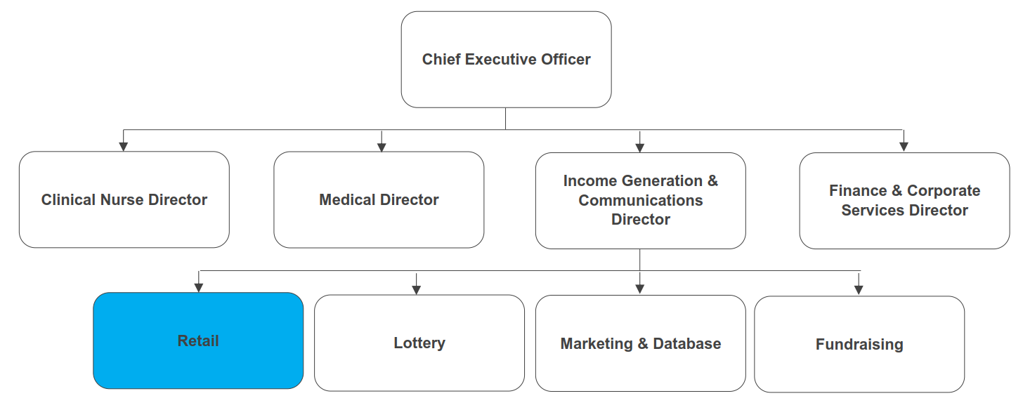
The duties and responsibilities of this post have been assessed as levels of competence required and reflect the skill and knowledge needed to satisfactorily perform the duties of the post.
Job Purpose: | To effectively manage the collection and delivery of items in relation to Bolton Hospice’s charity shops.
Key Working Relationships: | Shops Managers  Retail Administrator  Retail team  Income Generation & Communications team  Volunteers  Customers and donors

Role Responsibilities
Collection & Delivery Service Operations
- Undertake tasks as scheduled on a daily job sheet, employing effective time management and prioritisation and inform the Retail Administrator of any incomplete jobs.
- Collect donated stock from donors’ homes and other locations and distribute to the hospice’s charity shops or Furniture Plus store where appropriate.
- Deliver furniture items purchased in store at Furniture Plus to customers when required, ensuring care is taken of the sold goods and care and attention is paid at the customers property to avoid damage.
- Support the smooth running of shops when required.
- Collect weekly banking information and cash donations from shops and deliver them safely to the hospice as and when needed.
- Work closely with the Store Manager/Store Supervisor/Warehouse assistant to help improve shop standards and maintenance.
- Uphold high levels of customer service and respect donors property and stock donations at all times.
- Ensure the hospice vehicle is well driven and maintained, according to legal requirements.
- Complete all log checks for the vehicle and report any issues to the Store Manager/ Retail Administrator immediately.
- Develop and maintain good working relationships with the staff and volunteer team at Furniture Plus working closely with them to ensure they follow all necessary procedures when assisting with the unloading of goods from the furniture van.
- Communicate effectively with donors, showing empathy if they are dealing with a bereavement and being polite and respectful at all times.
- Understand and promote the Gift Aid scheme when collecting donations.
- Adhere to all Safe Systems of Work relating to all lifting aids, e.g. tail lift, trolleys, and pump trolleys.
- Ensure that only saleable items which adhere to Bolton Hospice policies are accepted, tactfully and sensitively declining acceptance of goods where necessary.
- Adhere to all procedures in relation to Health & Safety and Manual Handling.
- Assist staff and volunteers with manual tasks within the Furniture store as and when needed.
- Assist in managing all aspects of waste.
Teamwork & Collaboration
- Attend and contribute to retail team and Income Generation & Communications department meetings as required.
- Work as an integral part of the team, being sensitive to the needs of the whole team and supportive of other team members.
- Provide cover for other members of the retail team as and when required.
- Assist with manual tasks at fundraising events when required.
- Be able to work flexibly to meet service needs.
Other
- Work within agreed hospice policies, procedures and guidelines.
- Participate in an annual appraisal and undertake training to maintain and develop knowledge and skills as required.
- Any other duties as deemed necessary by the Store Manager, Furniture and E-Commerce Manager, Head of Retail or Director of Income Generation & Communications.

General Responsibilities:
Health and Safety
All employees have a duty to report and accidents, complaints, defects in equipment, near misses and untoward incidents, following hospice procedure. Ensure health and safety legislation is complied with at all times, including COSHH and Workplace Assessment.
Confidentiality
All information relating to patients, patients’ families, staff, volunteers, supporters and suppliers gained through your employment with Bolton Hospice is confidential. Disclosure to any unauthorised person is a serious disciplinary offence.
Infection Control
Prevent spread of infection. Comply with policies and procedures for correct disposal of waste, sharps and soiled linen.
Safeguarding Vulnerable People (Children and Adults)
All employees have a responsibility to protect and safeguard vulnerable people (children and adults). They must be aware of child and adult protection procedures and who to contact within the Hospice for further advice. All employees are required to attend safeguarding awareness training and to undertake additional training appropriate to their role.
The range of duties and responsibilities outlined above are indicative only and are intended to give a broad flavour of the range and type of duties that will be allocated. They are subject to modification in the light of changing service demands and the development requirements of the post holder.
Disclosure & Barring Service Check
This post is subject to a Disclosure & Barring Service check.
Continuous Personal Development
You are responsible for your own professional development, identifying training and development needs to your line manager and completing all mandatory training as required. You must attend any specialist training and development activities relevant to your role within the hospice.
Valuing Equality and Diversity
All hospice staff should carry out their duties in accordance with the values and principles of our Equality and Diversity strategy. It is the responsibility of all employees to support the hospice commitment to do all we can to ensure we do not exclude, alienate or discriminate in any way and to promote a positive attitude to equality and diversity in adherence to our Equality and Diversity policy.
Living Our Values Everyday
All staff must actively support the vision, aim and values of the hospice, promoting our core values at all times and in all aspects of your work.


The range of duties and responsibilities outlined above are indicative only and are intended to give a broad flavour of the range and type of duties that will be allocated. They are subject to modification in the light of changing service demands and the development requirements of the post holder.
This job description is an outline of the main responsibilities. It will be subject to periodic review and amendment.
Employee Name:
Employee Signature: |  | Date:

Manager Name:
Manager Signature: |  | Date:

PERSON SPECIFICATION

Job Title: | Collection & Delivery Operative
Department: | Income Generation & Communications
Grade: | Ancillary 2

The person specification sets out the qualifications, experience, skills, knowledge and personal attributes which the post holder requires to perform the job to a satisfactory level.

 | ESSENTIAL | DESIRABLE | METHOD OF ASSESSMENT
QUALIFICATIONS |  | Good standard of education | Application Form
EXPERIENCE | Experience driving a van  Experience of dealing with the public | Experience working within a retail environment  Experience of working with volunteers  Experience of driving a 2-tonne van (e.g. Citroen Luton or similar) | Application Form  Interview
SKILLS | Excellent customer service skills  Good communication and interpersonal skills |  | Application Form  Interview
KNOWLEDGE | Good knowledge of safe manual handling techniques | Knowledge of Health & Safety legislation in relation to the sale of furniture  Knowledge of the Bolton area | Application Form  Interview
PERSONAL ATTRIBUTES | Able to comfortably manage physically demanding work  Must have a full, clean UK driving licence.  Self-motivated and able to use initiative  Strong teamwork ethic  A commitment to the vision and values of Bolton Hospice |  | Application Form  Interview

