JOB DESCRIPTION
Job Title: | Nursing Associate
Department: | Clinical Nursing Team
Post Holder: | tbc
Grade: | Band 4
Reports to: | Service Lead
Accountable to: | Clinical Nurse Director
Organisation Chart:
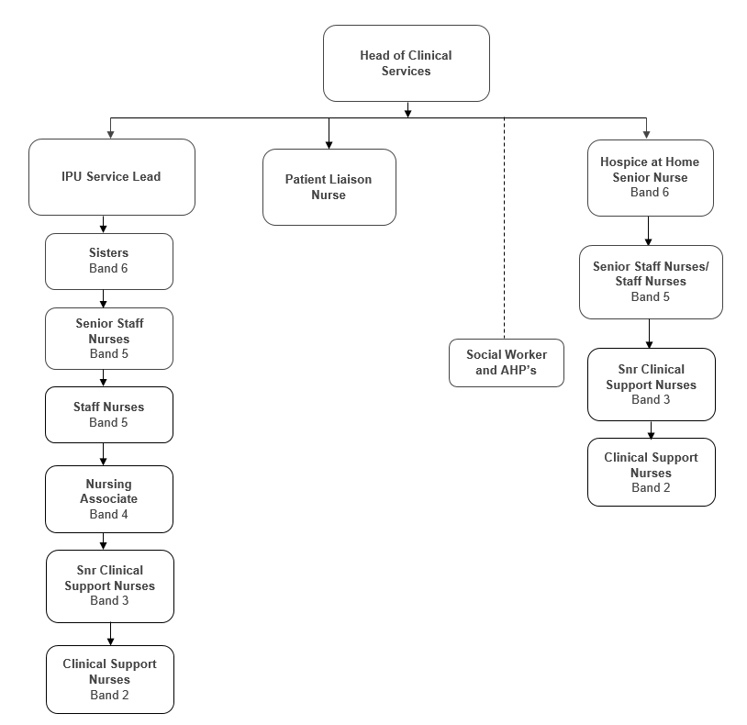

Job Purpose: | To work with the multi-disciplinary team and registered nursing staff to contribute to the ongoing assessment of patients, providing and monitoring care in line with the service pathways and as agreed with supervisor.  To monitor the condition and health needs of patients within the hospice in partnership with the wider multi-disciplinary team.  To use breadth of knowledge to provide holistic and person centred care and support for hospice patients, bridging the gap between Clinical Support Nurses and Staff Nurses by working independently under the leadership of the registered nursing staff and working within all aspects of the nursing process.
Key Working Relationships: | Head of Clinical Services  Service Leads  Sisters  All Nursing Staff  Consultants  Medical team  Administration team  AHPs  Social Workers  Catering, housekeepers and porters.  Creative Therapist  Complementary therapists  Volunteers

The duties and responsibilities of this post have been assessed as levels of competence required and reflect the skill and knowledge needed to satisfactorily perform the duties of the post.
Role Responsibilities:
Key Objectives
- Promote and maintain the philosophy of the hospice.
- Make decisions based upon knowledge and experience and be accountable for those decisions in the absence of the senior members of staff.
- Promote and maintain high quality patient care by acting as a role model for more junior staff.
- Ensure that all nursing care is carried out in accordance with Nursing & Midwifery Council Scope of Professional Practice.
- Assist in the delivery of Specialist Palliative Care to patients / families.
- Act in accordance with Bolton Hospice policies, procedures and protocols and within expected values and behaviours.
- Ensure standards are maintained at all times.
Professional / Clinical Practice
- Work in accordance with the Nursing & Midwifery Council Code of Conduct.
- Under the supervision of and working in partnership with a registered nurse, provide and monitor a high standard of nursing care based on evidence, contributing to the ongoing assessment of patients and working collaboratively with the multi-disciplinary team.
- Provide compassionate, safe and effective care and support to patients in a range of care settings.
- Monitor the condition and health needs of hospice patients on a continual basis, in partnership with patients, families and carers, ensuring appropriate escalation to a registered nurse when required.
- Support patients to improve and maintain their mental, physical and behavioural health and wellbeing.
- Promote comfort and wellbeing by ensuring that patients’ personal and social needs, as well as nursing needs, are met.
- Safely undertake the following routine procedures to meet patients’ nursing needs, to include:
  - venepuncture, ECG recording, measuring and interpreting blood glucose levels, recording and interpreting vital sign, continence care, bladder and bowel care, pressure area care, wound care, nutrition, hydration, foot care, skin integrity, mood identification (as outlined in the NMC Nursing Associate Skills Annex)
- Identify and report changes in a patient’s condition to a registered nurse.
- Prioritise and manage own workload, recognising where elements of care can safely be delegated to other colleagues, carers and family members.
- Provide and receive sensitive information concerning a patient’s medical condition.
- Work with the registered nurses and engage with other agencies and community teams to ensure a safe, individualised approach to the admission and discharge of patients.
- Maintain accurate, contemporaneous patient records, in line with hospice policy and the NMC Code.
- Provide effective evidence based care for service users under the supervision of registered nurses, in order to perform non-complex activities, in line with clinical governance and professional standards.
- Comply with NMC regulations relating to revalidation, in order to maintain NMC registration.
- Ensure accurate record keeping.
- Actively participate in and attend ward meetings.

Medicines Management and Administration
- Adhere to Bolton Hospice Management of Medicines Policy.
- Recognise the effects of medicines, allergies, drug sensitivity, side effects, contraindications and adverse reactions.
- Undertake safe and effective administration and optimisation of medicines, in accordance with hospice policy and the NMC standards of proficiency for Nursing Associates.
- Administer medicines via the following routes, in line with NMC Standards and hospice policies:
  - oral, topical, rectal, subcutaneous and intramuscular.
- Comply with hospice policy in relation to any safety critical medicines to be administered by Nursing Associates.
- Monitor the condition and health needs of hospice patients, following administration of medication.
- Recognise and report any situations, behaviours or errors that could result in poor care outcomes related to medicines management.
Evidence Based Care, Quality and Standards
- Identify relevant sources of evidence to inform practice.
- Critically consider and analyse own practice, in light of best available evidence.
- Contribute to surveys, audits, research activity, as required to own role, supporting recommended changes in practice.
- Ensure patients risk assessments are carried out daily
- Manage risk effectively.
- Have an awareness of the complaints procedure.
- Ensure equipment is maintained as appropriate, and necessary records are maintained.
Education and Training
- Comply with mandatory competencies, in line with hospice policy.
- Engage in a preceptorship period that includes achieving the Nursing Associate Medicines Management Competency Framework.
- Maintain own continuing professional development, in accordance with NMC CPD requirements and contribute to formulation of own objectives and personal development plan.
- Undertake a regular KSF review.
- Support, supervise, teach (where appropriate) and act as a role model to Trainee Nursing Associates, student nurses, Clinical Support Nurses and new staff members, promoting reflection and providing constructive feedback.
- Contribute to the maintenance of the learning environment.
- Adopt a reflective approach to own practice with a view to continually improve.
- Undertake further training as required, prior to carrying out any additional duties identified as relevant to the role, to comply with hospice policies and procedures.
- Keep up to date with issues in nursing and nursing research, especially those relating to palliative care nursing.
Clinical Governance
- Work with the clinical team to ensure that high standards of treatment and pathways of care, which are evidence based, documented and monitored, are in place.
- Manage clinical risk issues in collaboration with the Senior Staff.
- Promote the safety of patients, staff, visitors and volunteers at all times.

Communication
- Communicate effectively and with dignity and respect to all patients, relatives and others, giving consideration to potential barriers to understanding.
- Communicate effectively with colleagues, providing clear verbal, digital or written information and instructions when sharing information, delegating or handing over responsibility for care.
- Recognise and report any situations, behaviours or errors that could result in poor care outcomes.
- Report accidents, incidents, near misses or complaints, following Bolton Hospice policies and procedures.
- Contribute to a culture where all staff feel safe to raise their concerns and where speaking up about any concerns is a normal part of the routine.
- Promote the contribution of nursing within the multi-disciplinary team.
- Develop good communication and professional liaison with all other personnel and agencies involved in the service delivery of palliative care.
- Attend and participate in organisational meetings to ensure awareness of developments within the area of practice and organisationally.
- Help create an environment which reflects the Hospice’s philosophy and its specialist palliative care approach.
- Promote effective communication between members of the multi-disciplinary team and users of the service.
- Promote positive communications and relationships with the public.
Other
- The post holder may be required to rotate onto nights, or to different departments in the hospice, to reflect the needs of the service.
- Any other requirements as appropriate to the post and location.

General Responsibilities:
Health and Safety
All employees have a duty to report and accidents, complaints, defects in equipment, near misses and untoward incidents, following hospice procedure. Ensure health and safety legislation is complied with at all times, including COSHH and Workplace Assessment.
Confidentiality
All information relating to patients, patients’ families, staff, volunteers, supporters and suppliers gained through your employment with Bolton Hospice is confidential. Disclosure to any unauthorised person is a serious disciplinary offence.
Infection Control
Prevent spread of infection. Comply with policies and procedures for correct disposal of waste, sharps and soiled linen.
Training
Managers are required to take responsibility for their own and their staff’s development. All employees have a duty to attend mandatory training as required by the Hospice.
Safeguarding Vulnerable People (Children and Adults)
All employees have a responsibility to protect and safeguard vulnerable people (children and adults). They must be aware of child and adult protection procedures and who to contact within the Hospice for further advice. All employees are required to attend safeguarding awareness training and to undertake additional training appropriate to their role.

Disclosure & Barring Service Check
This post is subject to a Disclosure & Barring Service check.
Valuing Equality and Diversity
All hospice staff should carry out their duties in accordance with the values and principles of our Equality and Diversity strategy. It is the responsibility of all employees to support the hospice commitment to do all we can to ensure we do not exclude, alienate or discriminate in any way and to promote a positive attitude to equality and diversity in adherence to our Equality and Diversity policy.
The range of duties and responsibilities outlined above are indicative only and are intended to give a broad flavour of the range and type of duties that will be allocated. They are subject to modification in the light of changing service demands and the development requirements of the post holder.
This job description is an outline of the main responsibilities. It will be subject to periodic review and amendment.
Employee Name:
Employee Signature: |  | Date:

Manager Name:
Manager Signature: |  | Date:

PERSON SPECIFICATION

Job Title: | Nursing Associate
Department: | Clinical Nursing Team
Grade: | Band 4
The person specification sets out the qualifications, experience, skills, knowledge and personal attributes which the post holder requires to perform the job to a satisfactory level.
 | ESSENTIAL | DESIRABLE | METHOD OF ASSESSMENT
QUALIFICATIONS | Registered Nursing Associate on the NMC register with Foundation Degree.  GCSE Maths and English, Grade C or above (or equivalent) or Functional Skills Level 2 Maths and English. | Communication skills training. | Application Form
EXPERIENCE | Experience of working under appropriate supervision as part of a multi-disciplinary team.  Experience of providing and receiving complex sensitive information. | Experience in the specialty. | Application Form  Interview
SKILLS | Ability to evaluate own strengths and development needs, seeking advice where appropriate.  Ability to take part in reflective practice and clinical supervision activities.  Ability to organise and prioritise own delegated workload.  Ability to deal with non-routine and unpredictable workload and individual patient contact.  Ability to support, supervise, assess and act as a role model to students and more junior staff members.  Effective time management skills.  Able to maintain high standards of quality and accuracy in corporate and clinical record keeping.  Computer literate.  Excellent written, verbal and non-verbal communication skills at all levels and with patients/families and professionals. |  | Application Form  Interview
Continued overleaf…

 | ESSENTIAL | DESIRABLE | METHOD OF ASSESSMENT
KNOWLEDGE | Understanding of the scope of the Nursing Associate role within the nursing and multi-disciplinary team.  Understanding of how the role may contribute to service development.  Understanding and evidence of application of the NMC and other professional codes of conduct.  Knowledge of when to seek advice and escalate issues as appropriate.  Understanding of NMC Professional Revalidation requirements.  Understanding the importance of following procedures and treatment plans. |  | Application Form  Interview
PERSONAL ATTRIBUTES | Able to develop effective and appropriate relationships with patients/families and colleagues.  Positive approach to work.  Compassionate, caring and open minded.  Punctual, reliable and flexible.  Able to work proactively, independently and on own initiative.  Adaptable and able to work in a team environment.  Able to work under pressure.  A commitment to the vision and values of Bolton Hospice. |  | Application Form  Interview

