JOB DESCRIPTION
Job Title: | Complementary Therapist
Department: | Wellbeing Hub Services
Post Holder: | tbc
Grade: | NA
Reports to: | Wellbeing Hub Service Lead
Accountable to: | Deputy CEO

Organisation Chart:
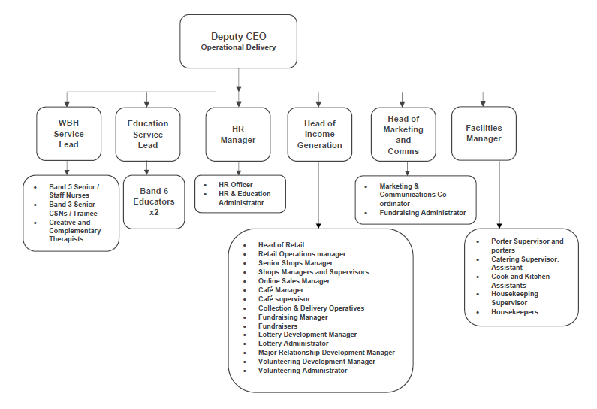

 | Job Purpose: | To provide Hospice approved complementary therapies to patients and their families/carers as well as employees of the Hospice
 | Key Working Relationships: | Head of Clinical Services  Deputy CEO  Service Leads  Complementary therapy colleagues  Wellbeing Hub Team  Members of the MDT  Housekeepers  Porters
The duties and responsibilities of this post have been assessed as levels of competence required and reflect the skill and knowledge needed to satisfactorily perform the duties of the post.

Role Responsibilities:
Key Objectives
- To deliver complementary therapies on a needs assessed basis to clients receiving Hospice services.
- To promote and maintain the philosophy of the hospice.
- Ensure standards are maintained at all times.
Professional / Therapeutic Practice
- To maintain the waiting list and arrange/amend client appointments.
- Accept clients onto the complementary therapy caseload.
- Monitor client’s attendance whilst accessing complementary therapies.
- To assess client’s needs and identify appropriate treatments approved for use by the Hospice and be able to modify the treatment within agreed level of competence.
- To monitor client’s wellbeing whilst receiving therapies; be able to recognise changes in the client’s condition and respond accordingly.
- To prepare the client and environment for therapeutic intervention as required.
- To maintain hygiene and cleanliness of all relevant therapy areas.
- Assist with and deliver group sessions as required within the Wellbeing Hub.
- Be aware of the other services available internally and externally and be able to access/signpost clients as necessary.
- To be responsible for organising and planning own caseload to meet service and client priorities – re-adjusting plans as situations change/arise.
- To ensure therapy equipment is fit for purpose and it is cleaned before and after use in line with infection control policy.
- Obtain informed consent that enables patient choice regarding their rights, care, treatment and their privacy and dignity is maintained, while attending complementary therapy.
- To demonstrate understanding of the roles of other multidisciplinary team members, work in partnership and attend and participate in regular team meetings/handovers to ensure good practice within the Wellbeing Hub and in-patient unit.
- To physically move and handle clients/equipment within health and safety guidelines maximising the client’s comfort.
- To be aware of local procedures for the provision of resources/services as required and complete referrals in liaison with relevant health professionals.
- Promote independence with clients whenever possible but when required assist clients with aspects of function and daily living e.g. dressing.
- Ensure appropriate and timely discharge of clients from allocated complementary therapy caseload.
- To possess basic IT and keyboard skills, enabling the use of relevant Hospice systems necessary to fulfil the role, e.g. entering contact data, maintaining electronic patient care records and accessing emails routinely.
- Responsible for the maintenance of adequate stock levels.
Evidence Based Care, Quality and Standards
- Be aware of the importance of clinical audit.
- Ensure that all the policies and procedures of Bolton Hospice are adhered to.
- Be aware of Risk Management.
- Have an awareness of the complaints procedure.
- Maintain personal and professional development.
- Ensure equipment is maintained as appropriate, and necessary records are maintained.
- Ensure therapies are evidenced based and utilise networking opportunities.
Organisational/Managerial/Leadership
- To promote the core values of the Hospice – Compassion, Excellence, Professionalism, Respect, Inclusivity, Collaboration.
- To exercise good personal time management.
- To exercise consistent reliable attendance to develop good and effective working practice.
- To maximise your efficiency within the team and the wider multidisciplinary team to meet the changing needs of the clients within your workload.
- To contribute to efficient use of resources by following stock control systems and other relevant departmental policies and guidelines.
- Participate in and contribute to service development, evaluation and changes through formal feedback mechanisms.
- To work at the expected high standard of quality and performance.
- Accept accountability for own actions and areas of responsibility.
- Act as a positive role model to the team and wider community.
- Treat everyone with respect and dignity.
- Work within the limits of your own competency and responsibility; refer issues outside your competency to the Wellbeing Hub Service Lead.
- To contribute to the recruitment and selection of complementary therapy staff.
- Participate in annual appraisal process.
- Have awareness of service budgetary needs.
Education and Training
- To demonstrate a basic knowledge of the Hospice services and client conditions/presentations associated with them.
- Take responsibility for own personal development, identifying training and development needs to Wellbeing Hub Service Lead.
- Keep up to date with skills and knowledge through accessing education and learning opportunities.
- To complete all mandatory training requirements of the post.
- Prepare evidence in support of performance to appraiser for annual appraisal.
- Be responsible for complying with your agreed personal development plan in order to achieve set knowledge and skills, objectives/competencies.
- Attend regular one to ones to reflect on own skills, practice and abilities.
- Deliver identifies teaching/training relevant to role.
Clinical Governance
- To have an awareness of the Hospice clinical governance framework and its implementation within the Wellbeing Hub.
- To adhere to the Complementary Therapy Operational Policy.
- To participate in clinical audit, surveys and one to ones.
- To report and actively participate in relevant investigations and learning from accidents, incidents and complaints.
- To respect the individuality, values, cultural and religious diversity of clients and contribute to the provision of a service sensitive to those needs.
- To work within own limits of competence, levels of responsibility and accountability within the team and the Hospice.
- Actively participate and contribute to the collection of service activity data.

- To contribute to the health, safety and wellbeing of clients, staff, volunteers and self by being aware of and adhering to Hospice policies and guidelines, by attending training and reporting any concerns to Wellbeing Hub Service Lead. Including Health and Safety at Work; Fire precautions and regulations; security, infection control; risk management and safeguarding.
- In line with the Hospice clinical record keeping standards all client related in-put is documented on the electronic iCARE record keeping system.
- To monitor, maintain, store, use and dispose of equipment in accordance with health and safety procedures.
- Support volunteers in their roles.
- Monitor the quality and effectiveness of aromatherapy oils.
- Ensure essential oils are stored safely and correctly.
- Ensure clients receiving complementary therapy have access to up to date service information.
- Contribute to the review and update of all client information on an annual basis.
Communication
- You will need a caring and compassionate nature and have excellent communication skills.
- To use a range of verbal and non-verbal communication skills/tools, to effectively communicate with and gather information from clients/carers to determine effectiveness of treatment. This will include clients who may have difficulties understanding or communicating.
- To communicate effectively within the team and the wider Multidisciplinary team the changing care needs of the clients and families within your workload.
- Communicate with other service users to provide support and efficiency, both internally and externally.
- Build and promote positive communications and relationships with the patients, carer’s and families as well as staff and supporters.
Other
- Undertake any other duties that are in keeping with the Hospice that you have the skill and ability to carry out.

General Responsibilities:
Health and Safety
All employees have a duty to report and accidents, complaints, defects in equipment, near misses and untoward incidents, following hospice procedure. Ensure health and safety legislation is complied with at all times, including COSHH and Workplace Assessment.
Confidentiality
All information relating to patients, patients’ families, staff, volunteers, supporters and suppliers gained through your employment with Bolton Hospice is confidential. Disclosure to any unauthorised person is a serious disciplinary offence.

Infection Prevention and Control
Prevent spread of infection. Comply with policies and procedures for correct disposal of waste, sharps and soiled linen.
Training
Managers are required to take responsibility for their own and their staff’s development. All employees have a duty to attend mandatory training as required by the Hospice.
Safeguarding Vulnerable People (Children and Adults)
All employees have a responsibility to protect and safeguard vulnerable people (children and adults). They must be aware of child and adult protection procedures and who to contact within the Hospice for further advice. All employees are required to attend safeguarding awareness training and to undertake additional training appropriate to their role.
Disclosure & Barring Service Check
This post is subject to a Disclosure & Barring Service check.
Valuing Equality and Diversity
All hospice staff should carry out their duties in accordance with the values and principles of our Equality and Diversity strategy. It is the responsibility of all employees to support the hospice commitment to do all we can to ensure we do not exclude, alienate or discriminate in any way and to promote a positive attitude to equality and diversity in adherence to our Equality and Diversity policy.
Living Our Values Everyday
All staff must actively support the vision, aim and values of the hospice, promoting our core values at all times and in all aspects of your work.

The range of duties and responsibilities outlined above are indicative only and are intended to give a broad flavour of the range and type of duties that will be allocated. They are subject to modification in the light of changing service demands and the development requirements of the post holder.
This job description is an outline of the main responsibilities. It will be subject to periodic review and amendment.
Employee Name:
Employee Signature: |  | Date:

Manager Name:
Manager Signature: |  | Date:

PERSON SPECIFICATION

Job Title: | Complementary Therapist
Department: | Wellbeing Hub Services
Grade:
The person specification sets out the qualifications, experience, skills, knowledge and personal attributes which the post holder requires to perform the job to a satisfactory level.
 | ESSENTIAL | DESIRABLE | METHOD OF ASSESSMENT
QUALIFICATIONS | - Diploma in Aromatherapy  - Certificate in Body Massage  - Diploma in Reflexology | - Reiki  - Indian Head Massage  - Crystal therapy  - Oncology massage training  - Other training relevant to role  - Registered with a Governing Body in their discipline | Application Form
EXPERIENCE | - Extensive experience in complementary therapy in a variety of settings. | - Previous experience of working in a hospice and/or health and social care environment.  - Experience in palliative care or life limiting conditions. | Application Form  Interview
SKILLS | - Ability to work well alone and as part of a team.  - Able to work independently with individuals and groups.  - Have effective written, verbal and non-verbal communication skills.  - Have basic computer skills including use of Microsoft Word, Excel and Outlook.  - Have good personal organisational skills.  - Efficient time management skills.  - Able to recognise and work within own personal limitations. | - Advanced I.T skills  - Ability to manage a busy workload.  - Ability to problem solve and respond to queries. | Application Form  Interview
KNOWLEDGE | - Awareness of palliative care. | - Knowledge of how disability/impairment affects function. | Application Form  Interview
PERSONAL ATTRIBUTES | - Able to work proactively, independently and on own initiative  - Able to work under pressure.  - Be able to undertake the physical aspects of the post such as moving and handling of clients and moving and cleaning equipment.  - Awareness of the Hospice’s charitable status and its reliance upon charitable donations which are influence by clinical care delivery and the professionalism of Hospice personnel. | - Full clean driving licence and access to own vehicle for business use subject to the provisions of the Equality Act 2010. | Application Form  Interview

