JOB DESCRIPTION
Job Title: | Macmillan Cancer Information and Support Service Assistant
Department: | Macmillan Cancer Information and Support Service
Employer Base: | Bolton Hospice
Post Holder: | tbc
Grade: | A&C Band 4
Reports to: | Macmillan Cancer Information and Support Service Managers
Organisation Chart:
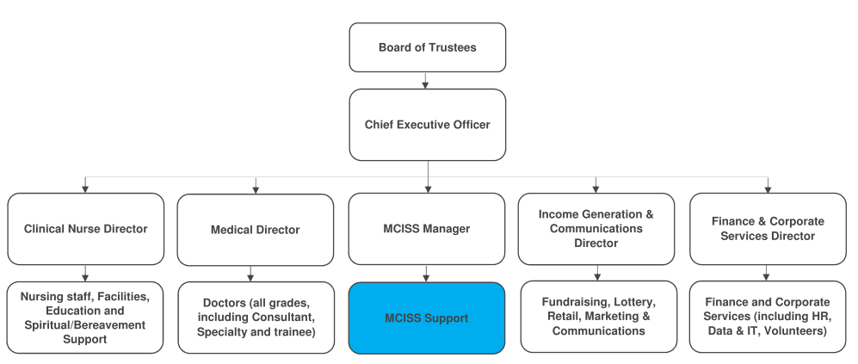
The duties and responsibilities of this post have been assessed as levels of competence required and reflect the skill and knowledge needed to satisfactorily perform the duties of the post.
Job Purpose: |  | To assist the Macmillan Cancer Information and Support Service (MCISS) team in developing and delivering the service in Bolton.  To meet with users of the service (e.g. patients/clients, carers, relatives and professionals) to support access to high quality information and support in relation to cancer. This will include the assessment of service users’ information and support needs, provision of verbal and written information, supportive listening, action planning and signposting to available services and support.  To assist with all new referrals to the Macmillan Benefits Advice Service.  To gather and collate data required for reporting, monitoring and quality assurance of the services.
Key Working Relationships: |  | Macmillan Cancer Information and Support Service team  Chief Executive (Bolton Hospice)  Lead Cancer Nurse & Cancer Nurse Specialists (Bolton Foundation Trust)  Bolton PAC Group  UCAN Centre Managers  Bolton Libraries Managers  Volunteers

Role Responsibilities:
Service
- Assist with all administrative duties necessary to ensure smooth running of the service, including appointments, diary maintenance, filing, photocopying and letter writing.
- Along with the other MCISS Assistant’s, deal with all new referrals to the Macmillan Benefits Advice Service, contacting referrals and triage referral as per the MCISS guidance, as well as managing the adviser’s diary and arranging 1:1 appointments with clients.
- Where appropriate, assist service users to complete the necessary benefit application forms following advice from the Macmillan Benefits Adviser.
- Where necessary, assess the needs of individuals who attend/contact the service and identify the required level of intervention, seeking advice from departmental managers where required. Contacts will be reviewed with the Service Manager on a regular basis to ensure they are being dealt with appropriately.
- Support service users sensitively to help them understand clinical information they may have been given (e.g. around diagnosis, treatment, effects of the illness and treatment, cancer terminology).
- Help to resolve situations where users feel they have been given conflicting information, including addressing concerns and queries and working to resolve them.
- Provide basic supporting information around topics such as reducing the risk of cancer, health living, diagnosis, treatment options, side effects and living with cancer, in the most appropriate format (e.g. written, verbal and others as appropriate).
- Where appropriate, liaise with relevant staff at all levels to address identified issues and/or seek advice on complex issues, directly involving others where necessary, e.g. Service Manager, Clinical Nurse Specialist etc. and ensuring that situations or enquiries requiring specialist intervention are referred appropriately and in a timely fashion.
- Contribute to the development and maintenance of effective relationships with stakeholders.
Operational
- Collect and collate data regarding user contacts with the service and produce activity reports as required.
- Maintain accurate stock records for information provided by the service.
- Organise an annual user satisfaction survey and collate and present the results for inclusion in the annual service report.
- Run routine queries, ad hoc queries and quality checks against the database systems, notifying the Service Managers of any potential circumstances which may impact on the service.
- Plan and organise events and display boards, both within the service and externally, liaising with third parties when required.
- Assist the Service Managers in the submission of monitoring reports.
- Support the role of the Service Managers, Deputy Managers, other staff, volunteers and Macmillan Benefits Adviser where necessary.
- Manage and maintain the social media aspects of the service. This would also include monitoring the usage of social media sites by the public and report the usage to the Service Managers.
- Keep the service website up to date.
- Develop leaflets, posters and other materials to recruit volunteers, support cancer awareness and to publicise the service and other events.
- Complete a monthly newsletter for distribution.
Information and Support
- Communicate sensitively and compassionately in potentially high emotive situations with clients (patients/families/carers) who may be very distressed.
- Provide both practical and emotional support to clients, giving them opportunity to acknowledge and express their concerns in a safe environment.
- Promote user participation in the development of the service, facilitate forums and/or attend meetings to increase this participation.
- Facilitate open and effective communication with the wider multi-professional teams, both internally and externally.
- Document and circulate minutes of meetings, as agreed with the Service Manager.
- Take part in reviewing the operational policy, ensure its implementation with the team and review at an agreed frequency.
- Work flexibly in order to deliver the objectives of the service, including attending events and outreach sessions in other areas of Bolton borough. Occasional evening and weekend work may be required.
Education and Training
- Administer and facilitate educational events, both internally and externally, which are relevant for Macmillan Cancer Information and Support Service users and professionals. This may include booking venues, developing and distributing flyers and registering attendees.
- Deliver pre-defined training to volunteers, centre users and staff from other departments, and using the system to retrieve resources for visitors to the centre.
- Keep up to date with current relevant issues and developments in cancer and palliative care.
- Assist in the co-ordination, mentoring and training of newly appointed volunteers and staff, supporting them during their induction.
- Demonstrate a willingness to identify own learning and development needs and be willing to undertake further study in order to address these needs.
Project Support
- Set up and maintain project files and collect actual data and forecasts.
- Administer or assist the Monitoring Group Meetings.
- Assist with the compilation and review of reports and update plans.
- Maintain service records and registers with the guidance of the Service Managers.
- Ensure the security and preservation of the master copies of all project products.
- Maintain a record of all copies issued.
- Notify holders of any changes to their copies.
- Number, record, store and distribute reports.
Working Conditions
- Lone worker for majority of patient intervention.
- Exposed to distressing situations on a regular basis.
- Frequent periods of intense concentration.
Other
- Work within agreed hospice policies, procedures and guidelines.
- Work as an integral part of the team, being sensitive to the needs of the whole team and supportive of other team members.
- Participate in an annual appraisal and undertake training to maintain and develop knowledge and skills as required.
- Provide cover for the Service Managers and Deputy Managers where required.
- Any other duties as deemed necessary by the Service Managers.

General Responsibilities:
Health and Safety
All employees have a duty to take reasonable care to avoid injury to themselves or to others and to co-operate with Bolton Hospice. All employees have a duty to report and accidents, complaints, defects in equipment, near misses and untoward incidents, following hospice procedure. Ensure health and safety legislation is complied with at all times, including COSHH and Workplace Assessment.
Confidentiality
All information relating to patients, patients’ families, staff, volunteers, supporters and suppliers gained through your employment with Bolton Hospice is confidential. Disclosure to any unauthorised person is a serious disciplinary offence.
Infection Control
Prevent spread of infection. Comply with policies and procedures for correct disposal of waste, sharps and soiled linen.
Training
Managers are required to take responsibility for their own and their staff’s development. All employees have a duty to attend training as required by the Hospice.
Safeguarding Vulnerable People (Children and Adults)
All employees have a responsibility to protect and safeguard vulnerable people (children and adults). They must be aware of child and adult protection procedures and who to contact within the Hospice for further advice. All employees are required to attend safeguarding awareness training and to undertake additional training appropriate to their role.
Disclosure & Barring Service Check
This post is subject to a Disclosure & Barring Service check.
Valuing Equality and Diversity
All hospice staff should carry out their duties in accordance with the values and principles of our Equality and Diversity strategy. It is the responsibility of all employees to support the hospice commitment to do all we can to ensure we do not exclude, alienate or discriminate in any way and to promote a positive attitude to equality and diversity in adherence to our Equality and Diversity policy.
The range of duties and responsibilities outlined above are indicative only and are intended to give a broad flavour of the range and type of duties that will be allocated. They are subject to modification in the light of changing service demands and the development requirements of the post holder.
This job description is an outline of the main responsibilities. It will be subject to periodic review and amendment.
Employee Name:
Employee Signature: |  | Date:

Manager Name:
Manager Signature: |  | Date:

PERSON SPECIFICATION

Job Title: | Macmillan Cancer Information and Support Service Assistant
Department: | Macmillan Cancer Information and Support Service
Grade: | A&C Band 4

The person specification sets out the qualifications, experience, skills, knowledge and personal attributes which the post holder requires to perform the job to a satisfactory level.

 | ESSENTIAL | DESIRABLE | METHOD OF ASSESSMENT
QUALIFICATIONS | NVQ Level 3 in Healthcare / Customer Care or equivalent  Communication Skills training e.g. Sage & Thyme  GCSE Grade C or above in English & Maths | Diploma or equivalent level of knowledge / experience  ECDL or other relevant IT training  Counselling certificate | Application Form  Certificates
EXPERIENCE | Experience of working with the general public  Experience of information provision and data analysis  Experience of working in a healthcare environment | Experience of working with volunteers  Experience of working in an oncology/cancer care environment. | Application Form  Interview
SKILLS | Good organisational and administrative skills, including being able to concentrate on data analysis, whilst prioritising own workload and meet deadlines as necessary  Able to develop effective interpersonal relationships with colleagues across a health and social care setting  Excellent communication skills- able to communicate effectively at all levels | Participation in service development and implementation of change  Working knowledge of health and wellbeing issues, the NHS and support services  Excellent IT skills in word processing, spreadsheets and production of information materials  Able to present information to professional groups  Excellent Social media knowledge and a high level of competence using social media platforms.  Ability to produce monthly newsletters using Canva software. | Application Form  Interview
KNOWLEDGE |  | Understanding of audit process  Knowledge of quality assurance issues around patient information | Application Form  Interview
Continued overleaf…

 | ESSENTIAL | DESIRABLE | METHOD OF ASSESSMENT
PERSONAL ATTRIBUTES | Able to recognise and work within the limit of own competence and responsibility  Self-motivated and able to use initiative  Strong teamwork ethic  Shows independent judgement, while operating within procedural guidelines  Ability to remain calm in stressful situations  Clean driving licence and access to a vehicle insured for business use  A commitment to the vision and values of Bolton Hospice. |  | Application Form  Interview

