JOB DESCRIPTION
Job Title: | Retail Assistant Manager
Department: | Income Generation & Communications
Post Holder: | Tbc
Grade: | Admin 1
Reports to: | Shop Manager
Responsible for: | Volunteers

Organisation Chart:
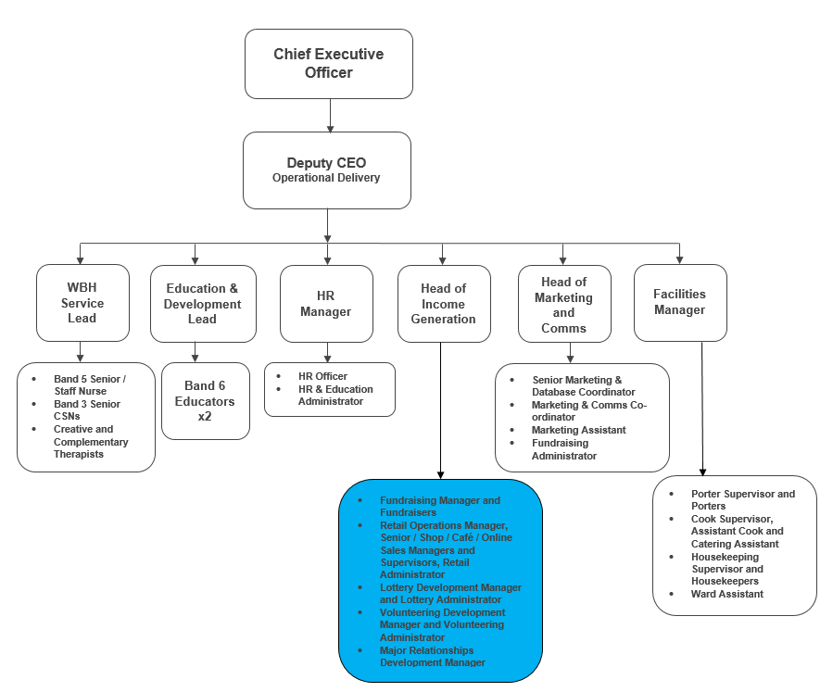
The duties and responsibilities of this post have been assessed as levels of competence required and reflect the skill and knowledge needed to satisfactorily perform the duties of the post.

 | Job Purpose: | To maximise profit for Bolton Hospice through the effective operational management of the shop.  Lead and motivate volunteers to deliver an excellent customer experience.
 | Key Working Relationships: | Retail team & Shop Team  Income Generation & Communications team  Volunteers  Donors and Customers

Role Responsibilities:
Shop Operations
- Manage (in conjunction with the Shop Manager) and develop the hospice’s retail operation, increasing profitability and maximising income from donated goods.
- Ensure the store is well organised and well run, with effective stock rotation and pricing policies in place to ensure consistency across different volunteer shifts.
- Maintain high standards across all aspects of the shop operation and particularly in relation to customer service, maintenance, Health & Safety and visual merchandising.
- Work closely with the Shop Manager to ensure the shop operation is consistently managed.
- Work closely with the volunteer team to ensure the back of house operation runs effectively, getting involved and covering tasks where necessary.
- Work closely with the Shop Manager and other team members to ensure sales and profitability targets are met.
- Ensure gift aid procedures in relation to the shop are adhered too, to make sure that gift aid income is maximised.
- Effectively deal with any customer complaints and act on customer feedback in consultation with the Shop Manager/ Retail Operations Manager to continually develop the shop customer experience.
- Utilise appropriate software and paper-based systems to safely and effectively manage volunteer information.
Leadership & Management
- Working with and supporting the Shop Manager, effectively recruit, train, supervise and motivate volunteers.
- Ensure all policies and procedures in relation to Health & Safety are adhered too in the store.
- Work closely with volunteers to ensure required standards and procedures are consistently maintained.
- Support the Shop Manager to ensure the shop always has adequate cover.
- Model the hospice’s values of compassion, respect, professionalism, excellence, inclusivity and collaboration and ensure they are reflected across the shop operation.
Financial & Reporting
- When required, take responsibility for cash handling and financial procedures, including cashing up, reconciliation, managing floats, petty cash and banking.
- Be aware of the shops financial KPIs.
- Proactively minimise costs associated with the shop.
Teamwork & Collaboration
- Work as an integral part of the team, being sensitive to the needs of the whole team and supportive of other team members.
- Provide cover for other members of the retail team as required.
Other
- Work within agreed hospice policies, procedures and guidelines.
- Participate in an annual appraisal and undertake training to maintain and develop knowledge and skills as required.
- Any other duties as deemed necessary by the Shop Manager, Retail Operations Manager, Head of Income Generation.

General Responsibilities:
Health and Safety
All employees have a duty to report and accidents, complaints, defects in equipment, near misses and untoward incidents, following hospice procedure. Ensure health and safety legislation is always complied with, including COSHH and Workplace Assessment.
Confidentiality
All information relating to patients, patients’ families, staff, volunteers, supporters and suppliers gained through your employment with Bolton Hospice is confidential. Disclosure to any unauthorised person is a serious disciplinary offence.
Infection Control
Prevent spread of infection. Comply with policies and procedures for correct disposal of waste, sharps and soiled linen.
Safeguarding Vulnerable People (Children and Adults)
All employees have a responsibility to protect and safeguard vulnerable people (children and adults). They must be aware of child and adult protection procedures and who to contact within the Hospice for further advice. All employees are required to attend safeguarding awareness training and to undertake additional training appropriate to their role.
The range of duties and responsibilities outlined above are indicative only and are intended to give a broad flavour of the range and type of duties that will be allocated. They are subject to modification in the light of changing service demands and the development requirements of the post holder.
Disclosure & Barring Service Check
This post is subject to a Disclosure & Barring Service check.
Continuous Personal Development
You are responsible for your own professional development, identifying training and development needs to your line manager and completing all mandatory training as required. You must attend any specialist training and development activities relevant to your role within the hospice.
Valuing Equality and Diversity
All hospice staff should carry out their duties in accordance with the values and principles of our Equality and Diversity strategy. It is the responsibility of all employees to support the hospice commitment to do all we can to ensure we do not exclude, alienate or discriminate in any way and to promote a positive attitude to equality and diversity in adherence to our Equality and Diversity policy.
Living Our Values Everyday
All staff must actively support the vision, aim and values of the hospice, promoting our core values at all times and in all aspects of your work.


The range of duties and responsibilities outlined above are indicative only and are intended to give a broad flavour of the range and type of duties that will be allocated. They are subject to modification in the light of changing service demands and the development requirements of the post holder.
This job description is an outline of the main responsibilities. It will be subject to periodic review and amendment.
Employee Name:
Employee Signature: |  | Date:

Manager Name:
Manager Signature: |  | Date:

PERSON SPECIFICATION

Job Title: | Retail Assistant Manager
Department: | Income Generation & Communications
Grade:

The person specification sets out the qualifications, experience, skills, knowledge and personal attributes which the post holder requires to perform the job to a satisfactory level.

 | ESSENTIAL | DESIRABLE | METHOD OF ASSESSMENT
QUALIFICATIONS | A good standard of numeracy and literacy |  | Application Form
EXPERIENCE | Experience working within a retail environment  Experience of working with volunteers  Experience of dealing with the public | Experience of working in the charity sector  Experience of recruiting / managing volunteers  Experience of working to and achieving financial targets | Application Form  Interview
SKILLS | Excellent customer service skills  Excellent organisational skills  Excellent communication and interpersonal skills - able to work alongside volunteers from all walks of life with varying learning abilities |  | Application Form  Interview
KNOWLEDGE | Computer literate - Microsoft Office, internet and email | Knowledge of Health & Safety legislation in relation to retail  Knowledge of gift aid administration in relation to retail | Application Form  Interview
PERSONAL ATTRIBUTES | Self-motivated and able to use initiative  Able to plan, manage and prioritise own workload  Able to work on a number of projects simultaneously  Able to work under pressure and to deadlines  Strong teamwork ethic  Willingness to work weekends on a rota basis to fulfil the requirements of the post  A commitment to the vision and values of Bolton Hospice | Commitment to continuous professional development  A full driving licence and access to a vehicle insured for business use | Application Form  Interview

